Name: _______________________ Class: __________ Date: _______
Instructions: Write answers in the right-hand column. Score: ___________ / 23 marks

Section A—Multiple choice (10 marks)

 | If the following reactions were carried out in thermally insulated containers, for which ones would the temperature of the mixture increase as the reaction occurs?  i Zn(s) + Br₂(l) → ZnBr₂(s); ∆H = –329 kJ  ii Na₂S₂O₃∙5H₂O(s) + 45 kJ → Na₂S₂O₃(aq) + 5H₂O(l)  iii PBr₅(g) → PBr₃(g) + Br₂(g); ∆H = + 105 kJ  iv Pb²⁺(aq) + 2I–(aq) → PbI₂(s) + 63 kJ  A ii and iii  B i and ii  C iii and iv  D i and iv | D | 1
 | 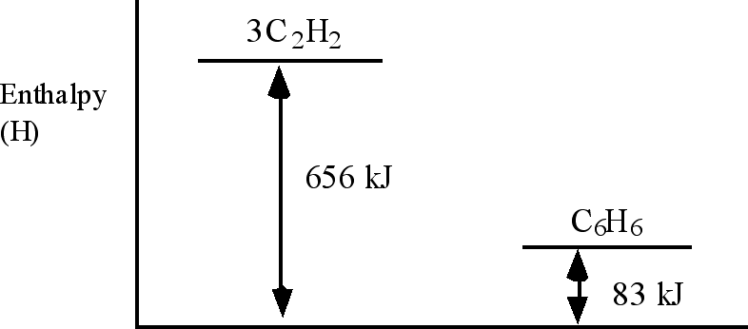  Use the information in the above diagram to calculate ∆H for the reaction  3C₂H₂(g) → C₆H₆(g)  A +739 kJ  B +573 kJ  C –573 kJ  D –656 kJ | C | 1
 | Magnesium combines with oxygen according to the equation  2Mg(s) + O₂(g) → 2MgO(s) + 1204 kJ  Which one of the following statements concerning this reaction is true?  A The reaction is endothermic.  B The temperature of the surroundings will decrease when the reaction occurs.  C The enthalpy of the product will be less than the enthalpy of the reactants.  D The energy required to break the bonds in magnesium and oxygen will be greater than the energy released in the forming of the bonds in magnesium oxide. | C | 1

Questions 4 and 5 refer to the following graph which shows the volume of hydrogen produced against time during a rate of reaction experiment between zinc and dilute hydrochloric acid.
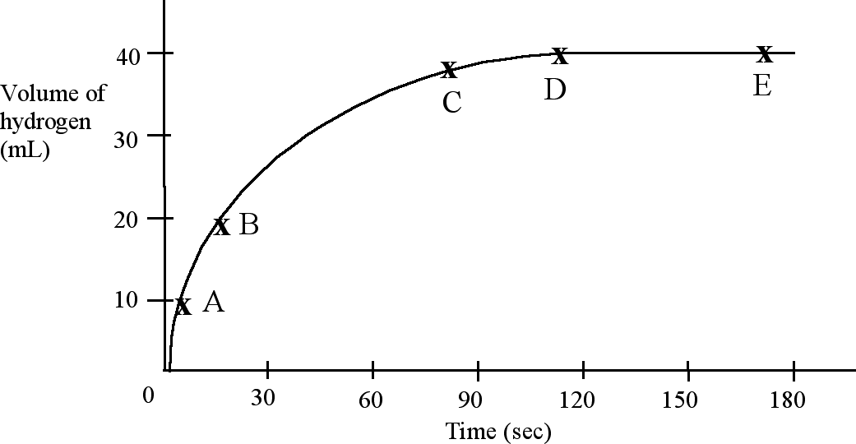
 | At which point in the graph is the reaction rate the greatest? | A | 1
 | At which point is the reaction complete? | D | 1
 | In a chemical reaction it is correct to say that (choose one answer):  A the activated complex has a lower energy than either the reactants or products.  B most collisions involve only two particles.  C a successful collision is one in which the reactants are re–formed.  D the rate can be determined by inspection of the stoichiometric equation. | B | 1
 | ‘The rates of all chemical reactions increase with a rise in temperature.’  This statement is (choose one answer):  A true, since the activation energies for all reactions increase with a rise in temperature.  B false, since the rate of an exothermic reaction decreases with a rise in temperature.  C false, since the rate of an endothermic reaction decreases with a rise in temperature.  D true, since a greater proportion of molecular collisions will result in reaction. | D | 1
 | For the reaction 2NH₃(g) → N₂(g) + 3H₂(g); ∆H = + 92 kJ, which one of the following statements is correct?  A When 4 mole of ammonia decomposes, 92 kJ of heat will be evolved.  B When 1 mole of nitrogen reacts with 3 moles of hydrogen, 92 kJ of heat will be absorbed by the system.  C When 1 mole of ammonia reacts, 46 kJ of heat will be absorbed from the surroundings.  D When 2 mole of ammonia decomposes, the temperature will decrease by 92ºC. | C | 1
Time  Relative energy  kJ  0  20  40  60  reactants  products | The following information refers to questions 9 and 10.  Examine the following potential energy diagram for a chemical reaction:  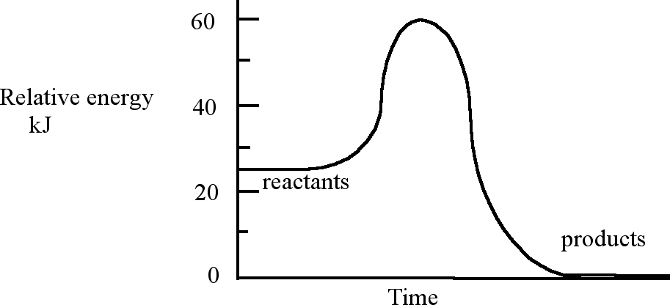
 | The enthalpy change ∆H and the activation energy E_{a} in kJ for the reaction are respectively  A ∆H = –25 kJ and E_{a} = 35 kJ  B ∆H = +25 kJ and E_{a} = 35 kJ  C ∆H = 35 kJ and E_{a} = 60 kJ  D ∆H = –60 kJ and E_{a} = 35 kJ | A | 1
 | If a catalyst is added to the system (choose one answer):  A both ΔH and E_{a} decrease  B ∆H remains constant but E_{a} decreases  C ∆H decreases and E_{a} remains constant  D both ∆H and E_{a} remain constant. | B | 1

Section B—Written answers (13 marks)

 | A compound of antimony, antimony sulfide, is used to make safety matches. A small amount of antimony sulfide is mixed with potassium chlorate and glued to the tip of the matchstick. When the match is struck on the side of the matchbox, the red phosphorus on the side of the box ignites, which in turn ignites the antimony sulfide/potassium chlorate mixture. Heat from this reaction then makes the match wood burn.  a Predict the formula of antimony sulfide (which contains the Sb³⁺ ion) and potassium chlorate.  b When antimony sulfide and potassium chlorate react, they form antimony oxide, potassium chloride and sulfur dioxide. Write a balanced equation for this reaction.  c Is this reaction an exothermic reaction or an endothermic reaction? Explain how you decided your answer.  d Sketch an energy profile diagram, for the reaction of antimony sulfide with potassium chlorate, indicating the relative potential energies of the reactants and products and the activation energy.  e Using the collision theory, explain why antimony sulfide and potassium chlorate do not react when the match is stored under normal conditions, but once struck on the side of the box, a reaction occurs. | a Sb₂S₃; KClO₃  b Sb₂S₃(s) + 3KClO₃(s) →  3KCl(s) + Sb₂O₃(s) + 3SO₂(g)  c Exothermic because when the antimony sulfide/ potassium chlorate mixture reacts, there is sufficient heat to make the wood in the match burn  d  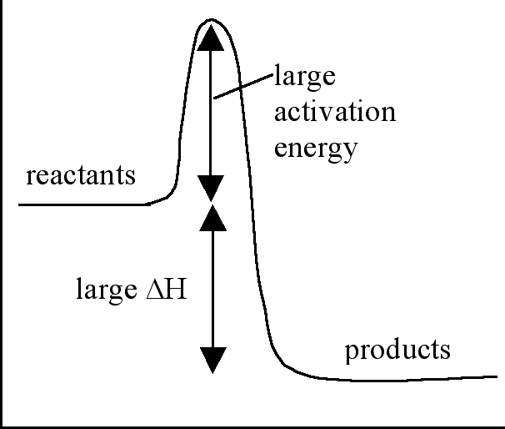  e The heat produced from the burning of the phosphorus (on the side of the box) increases the average kinetic energy of the antimony sulfide and potassium chlorate particles. As a result, more of these particles will have the required activation energy, when they collide, for a reaction to occur. | 7
 | The fizzy sensation from sherbet lolly powder is caused by a gas produced in a reaction between two substances. The sherbet powder consists of the two dry reactants citric acid, C₆H₈O₇, and sodium hydrogencarbonate, and a sweetener such as icing sugar. The gas-producing chemical reaction does not begin until the dry ingredients become wet. As soon as they dissolve into the saliva in your mouth, the reaction begins. In this reaction the citric acid reacts with the hydrogencarbonate ions to form carbon dioxide (the fizz), water and citrate ions, C₆H₅O₇^{3–}.  a Explain in terms of the collision theory why a reaction occurs much quicker when the two reactants are ‘wet’.  b If some sherbet powder were to be poured into hot water, would you expect the rate of ‘fizz production’ to change? Explain your answer in terms of the collision theory. | a The reactants, citric acid and sodium hydrogencarbonate must be close enough to collide and have enough energy to overcome the activation energy barrier. This is more likely to take place in solution where the dissolved citric acid molecules and hydrogencarbonate ions are moving around and are more likely to undergo collision.  b The average kinetic energy of the particles is greater at the higher temperature. The reaction rate would be increased at the higher temperature as there will be more collisions between the faster moving particles and, more importantly, these particles will have more energy and so the chance of collisions with sufficient activation energy to react will be greater. | 4
 | Acetic acid, CH₃COOH, is industrially manufactured from methanol according to the following reaction  CH₃OH(l) + CO(g) → CH₃COOH(l);  ∆H = –137 kJ mol^{–1}  The most modern chemical plants now use rhodium, Rh, as a catalyst for this reaction.  a  i What is meant by the term ‘∆H = –137 kJ mol^{–1}’ written after the chemical equation.  ii Calculate the amount of heat released or absorbed when 100 g of acetic acid is formed in the reaction given above.  b  i What is the role of a catalyst in a reaction?  ii In terms of the collision theory, explain how a catalyst affects the rate of a reaction. Include an energy profile of the reaction in your answer. | a i When the reaction takes place according to the stoichiometry of the given equation, then 137 kJ of heat energy will be released to the surroundings.  ii n(acetic acid) = 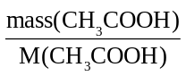  = 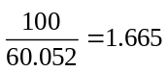mol  Since 137 kJ is produced when 1 mole of acetic acid is formed, the energy released when 1.665 mole of acetic acid is formed, = 1.665 × 137 = 228 kJ  b i A catalyst provides an alternative reaction pathway with lower activation energy for reaction.  ii Since the catalyst provides a pathway with a lower activation energy it is more likely that collisions between reacting particles will have enough energy to provide this activation energy. Thus the rate of reaction will be greater.  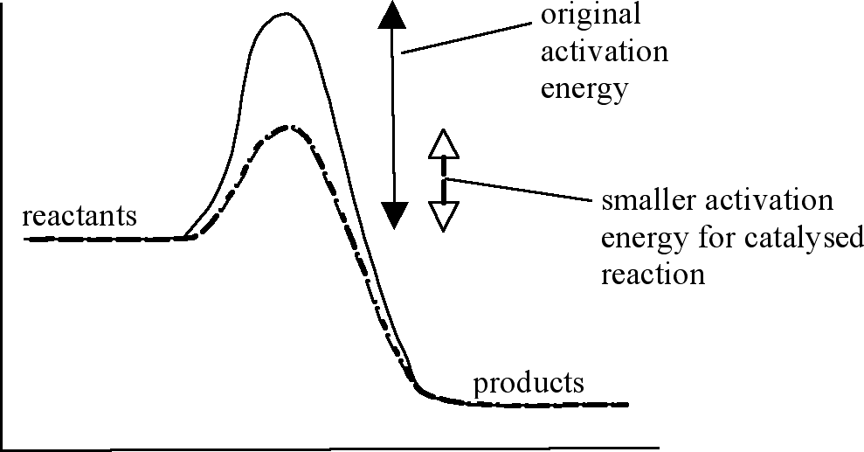 | 2

